
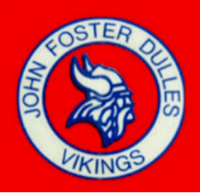
Y.E.S. Registration form
Dulles High School

Dear Student:

One of the distinctive characteristics of the United States is our conviction that everyone can make a difference through volunteer service. This is reflected in the recent trend of colleges asking for community service involvement as one of their criteria for acceptance. The Y.E.S. Program provides our students with the opportunity to get involved through voluntary service at the local level and to make a difference in their own neighborhoods and communities.
Please visit the YES web page for specific information and guidelines on the YES program.
https://www.fortbendisd.com/Page/92872
I understand that to fulfill the requirements for Community service through the Yes program, I must complete the required 100 hours and submit the documentation before March 31st of my senior year.

Student Name ___________________________ID _____________Graduating year__________
Student signature _______________Date __________Parent Signature __________________Date___________

Please submit registration form to Nicola.henry@fortbendisd.gov or you may deliver a copy of your form to the C-wing Counseling office at DHS.

PLEASE KEEP A COPY OF THIS FORM FOR YOUR RECORDS

